Design

Modeled after the triple-A title Super Mario but hailing back to the early years of gaming on the Nintendo Entertainment System, the game is a platformer by design.

Development

Development was performed using the Unity3D Game Engine, available for free from [www.Unity3D.com](http://www.Unity3D.com). As well, the art assets for the game were collected from the open source website [www.OpenGame](http://www.OpenGame)Art.org.

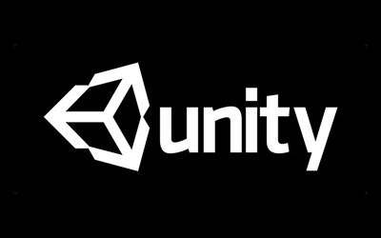



Gameplay

While playing the game, the player navigates using the keyboard pressing keys to move to the right or left, and to jump. When the player is confronted with an enemy, such as a spider, the player need only jump and land on the monster, stomping or killing them.